**Major Fixes we need asap please:**

**The Fresh, Gadgetshop and Zoodle pages.**

These are still all missing the about us text to go on their pages. This template differs from the WHSmith, Wild and Supanews pages. The fresh, gadgetshop and zoodle pages all only have one page of content so we don’t need quick links for these. We just need the about us page content to be placed below the logo and above the map. You can see what we need on the below design. Can we please replicate this, we don't want a quick links section.

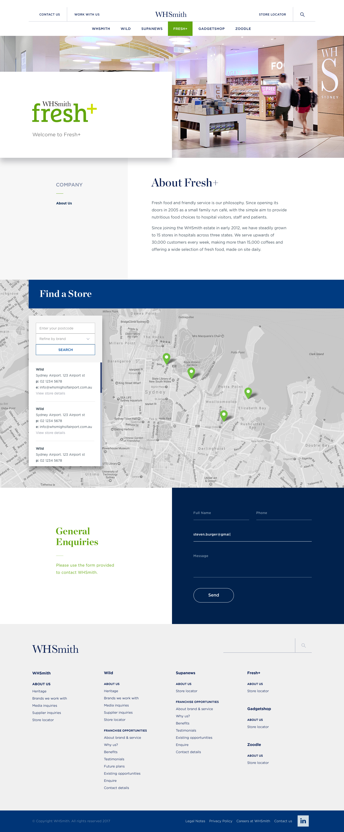

**Wild Pages**

• Wild company page. http://whsmith.wpengine.com/about-us/  
This page template is currently missing the ‘proud member of NRA’, social links, store locator and ‘view our latest catalogue’. This would be the page template for all wild company pagees. We don’t want to have to build all of these pages everytime we create a new one. We just want it to be the default. Please see below the page design we need replicated. I would hope this is just a matter of us selecting under page template ‘wild company’ and this template would be used.

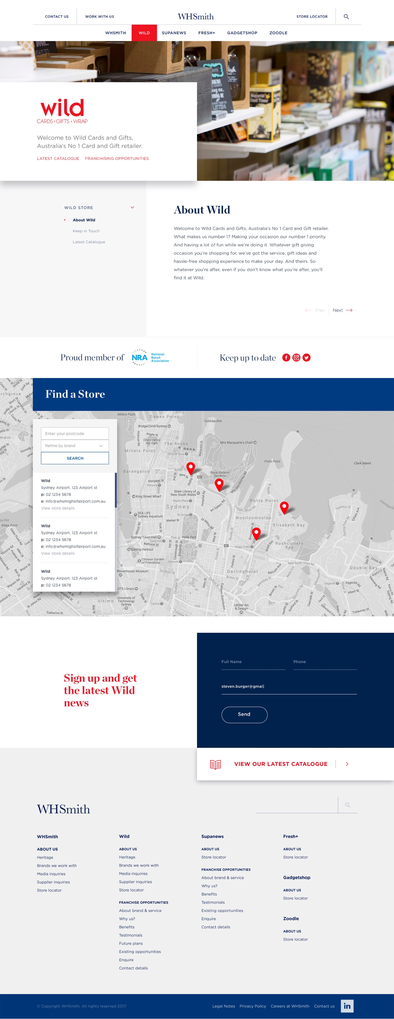

**Wild franchising opportunities pages:**

Can the same be applied for the wild franchising pages. This page template just needs the ‘proud member of FCA’, and the franchise enquiries form section. Can we please replicate the below. I would hope this is just a matter of us selecting under page template ‘wild franchising’ and this template would be used. Additionally, the left hand nav where ‘learn about wild’ and ‘become a franchisee’, the page links bleed all the way to the edge of the grey. Can thse please be tidied like the below design as well.

